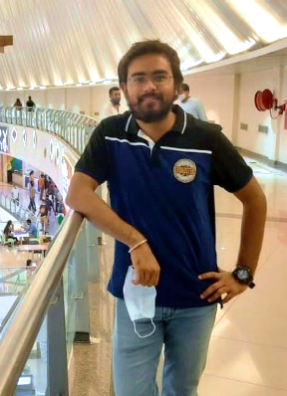

Mobile Smartphone Icon - Free vector graphic on PixabayKundan Kumar

[Hello1234@gmail.com](mailto:Hello1234@gmail.com)

+91 123456789, 123456789

India

[linkedin.com/in/kundan-kumar](https://www.linkedin.com/in/kundan-kumar-721725186/)

<https://leetcode.com/kundankumar4348/>

GPS icon PNG images free downloadPursuing MCA from NIT KURUKSHETRA



File:LeetCode logo black.png - Wikimedia Commons

Fresher, Technology Lover, open for challenges, has a good grip on Data Structures and Algorithms.

Quick Learner with Leadership quality.

**SUMMARY**

* Good grip on **Data Structures** and **Algorithms.**
* Worked on multiple **Collection Framework** (**HashMap, set, stack, queue, priority queue, Linked List, Trees, Graphs**, **Trie, Union & Find etc**).
* Good knowledge about **Object Oriented Programming**.

**PROJECT TECHNICAL SKILLS**

**Sentiment Analysis bots (ML , Python , TextBlob)**

Algorithms

Data Structures

C++

* Creating **multiple Sentiment Analysis bots** which will keep

**track of the comments** posted on Reddit and Twitter

ReactJs

JavaScript

CSS

HTML

**regarding Bitcoins** and then will suggest the best **time**

**to buy or sell bitcoins** on Binance website.

* Created our **own Sentiment model** and trained that **ACHIEVEMENTS**

model with our **own training data** for analysing sentiments

* A **4 Star** coder on Leetcode, solved over **1189 questions** with multiple **Badges** Earned (DP, Monthly Badges etc.)
* Given multiple **Contests** on different platforms with **Global Ranking** of **27,227** onLeetcode(currently).
* **Diploma Degree** Certification in **Classical Singing**.
* **Diploma Degree** Certification in **Web Designing.**

of reviews extracted from twitter.

**Expense Tracker ( ReactJs)**

* **Keeps the track of expenses** of each month sorted by year.
* **Add new Expenses** or **delete any added Expense**.

**Project on Apache Kafka (Kafka, Twitter API, TextBlob)**

* **Created a Producer API** which extracts data from

twitter and then sends it to specified topic in Apache Kafka.

* **Created a Consumer API** which consumes the data from

the specified topic and sends it to spark.

* **Analysing the data** on the basis of negative, positive and

Neutral using TextBlob.

**EDUCATION CO-CURRICULAR**

**Post-Graduation** - Diploma Degree in Music.

Course Master in Computer Application(currently)

**PERSONAL DETAILS**

**DOB-** 23/03/1999

**LANGUAGES KNOWN**

* English
* Hindi

**HOBBIES**

* Singing
* Playing Guitar
* Solving Rubik’s Cube
* Reading Inspirational Books

College NIT Kurukshetra

Year of Passing Graduating in July 2023

Score 8.5/10(till 3rd semester)

**Graduation**

Course BSc. IT (Computer)

College Marwari College, Ranchi

Year of Passing Oct 2020

Score 71.47%